Ideation Phase
Brainstorm & Idea Prioritization Template

Date | 30 November 2025
Team ID
Project Name | Freelancing Application
Maximum Marks | 4 Marks

Brainstorm & Idea Prioritization Template:
Brainstorming promotes an open and collaborative environment that supports innovative thinking and idea expansion. Encouraging high-volume idea generation helps teams unlock creative paths and refine promising concepts together.
Step-1: Team Gathering, Collaboration and Select the Problem Statement
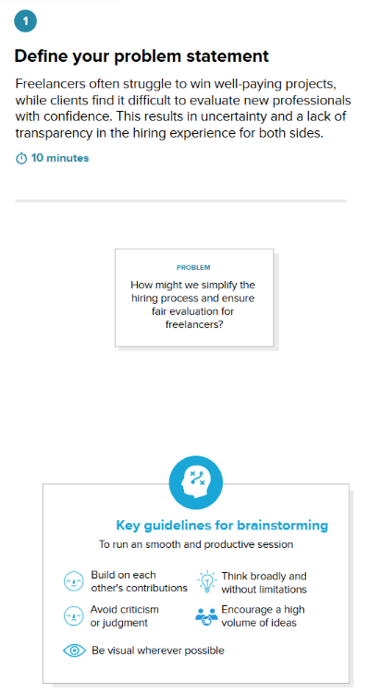

Step-2: Brainstorm, Idea Listing and Grouping
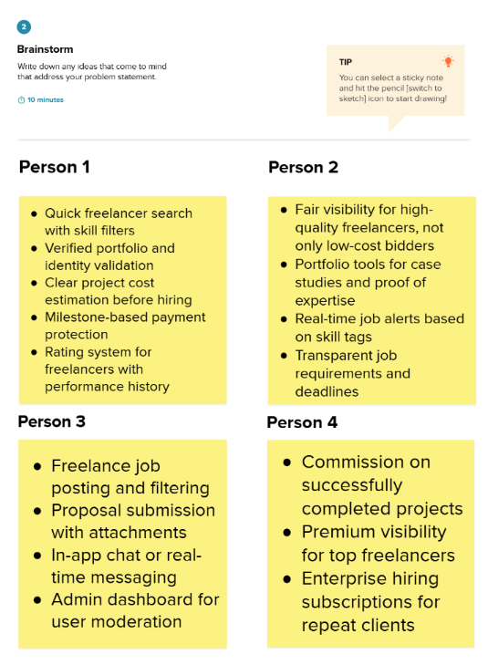
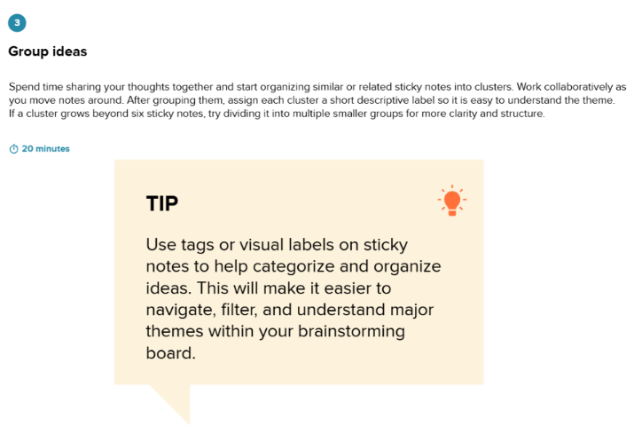

Step-3: Idea Prioritization
